Backup Job and Data from Vault Deletion Procedure

To delete a backup job and delete job data from vaults:
- When signed in as an Admin user, click Computers on the navigation bar.
  - The Computers page shows registered computers.
- Find the computer with the job that you want to delete, and expand its view by clicking its row.
- Click the Jobs tab.
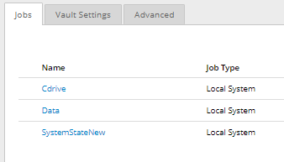
- In the Select Action menu of the job that you want to delete, click Delete Job. A Delete Job dialog box appears if your Portal instance supports data deletion.
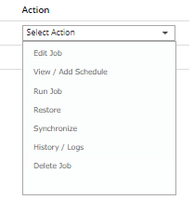
  - Note: If the Delete Job dialog box does not appear, you cannot request that data for the job should be deleted from vaults. You can only delete the job from Portal.

- Select Fully delete job, and then click Delete.
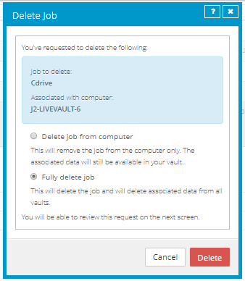
  - A confirmation dialog box asks you to confirm the deletion request.
- In the text box, type CONFIRM.
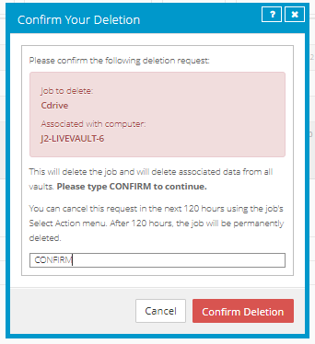
  - Note: You must type CONFIRM in capital letters.
- Click Confirm Deletion.
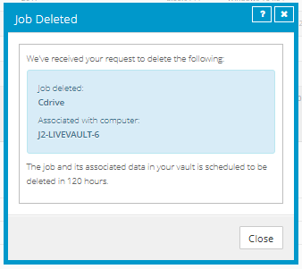
  - A Job Deleted dialog box states that the job and its associated data in your vault is scheduled to be deleted.
- Click Close.
  - The Last Backup Status column shows Scheduled For Deletion for the job.
  - The Date column shows the date when the job will be deleted from Portal and job data will be deleted from vaults. Within a day of the scheduled deletion, the Date column will also show the time when the job and its data will be deleted.
  - An email is sent to Admin users for the site and Super users to indicate that the job deletion has been scheduled.

